Policies_Verifying Agency Billed Policy_Instance43_15-Jun-2018_07-04-38_AM_ValidatingPolicysubentitynavigation.png

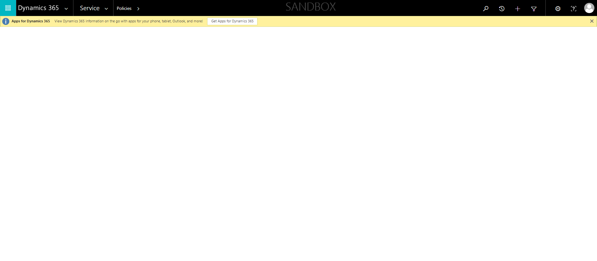

Policies_Verifying Agency Billed Policy_Instance43_15-Jun-2018_07-02-42_AM_MouseClickActiononStaleElement.png

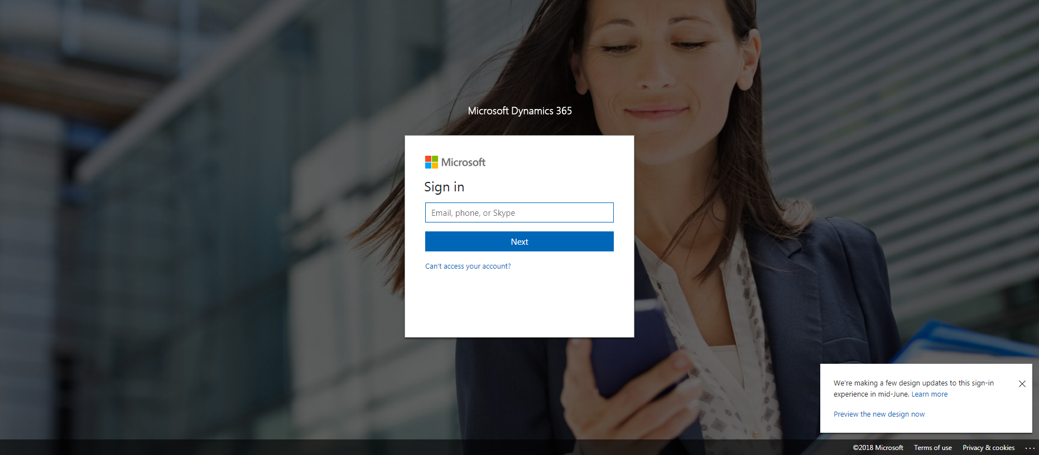

Policies_Verifying Agency Billed Policy_Instance43_15-Jun-2018_07-04-44_AM_ValidationofAgencyBilledPolicy.png

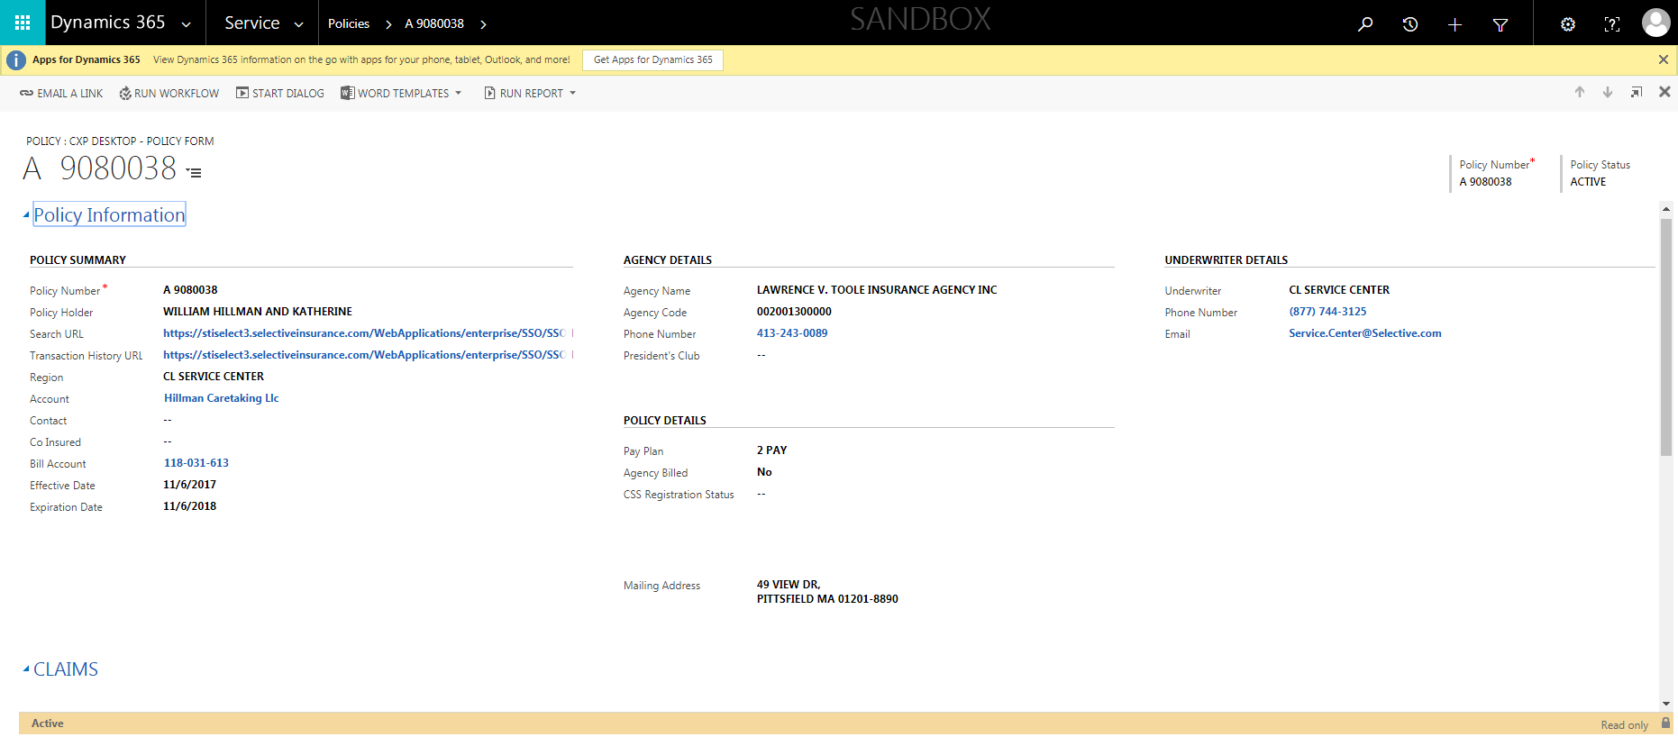

Policies_Verifying Agency Billed Policy_Instance43_15-Jun-2018_07-04-31_AM_ValidatingPolicyentitynavigation.png

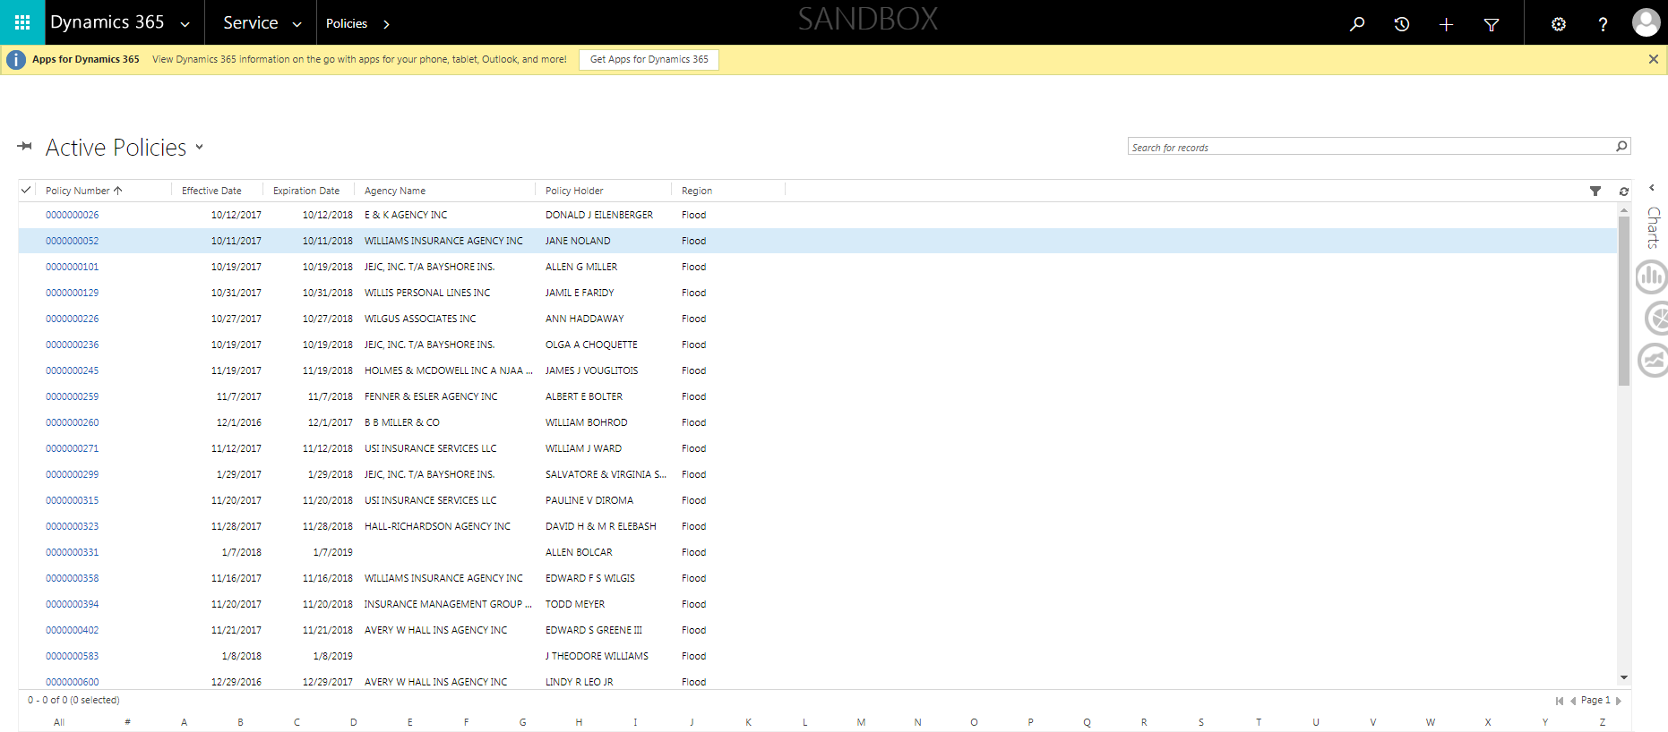

Policies_Verifying Agency Billed Policy_Instance43_15-Jun-2018_07-02-46_AM_MouseClickActiononStaleElement.png

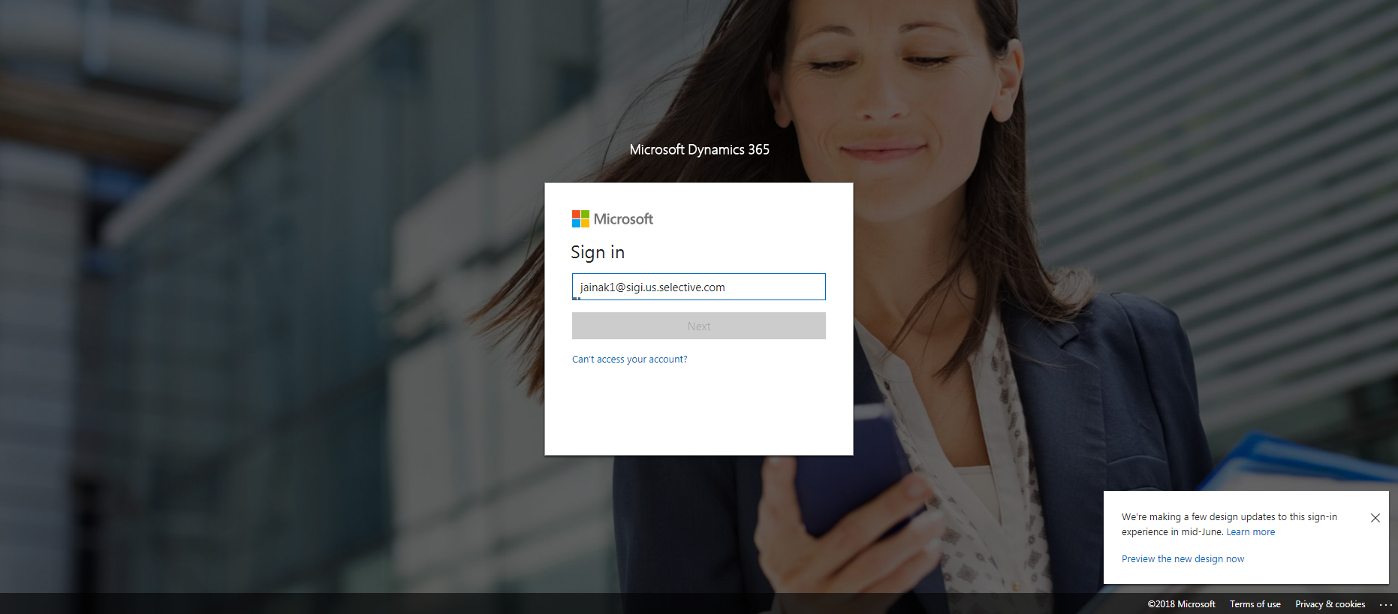

Policies_Verifying Agency Billed Policy_Instance43_15-Jun-2018_07-02-44_AM_EnterTextAction.png

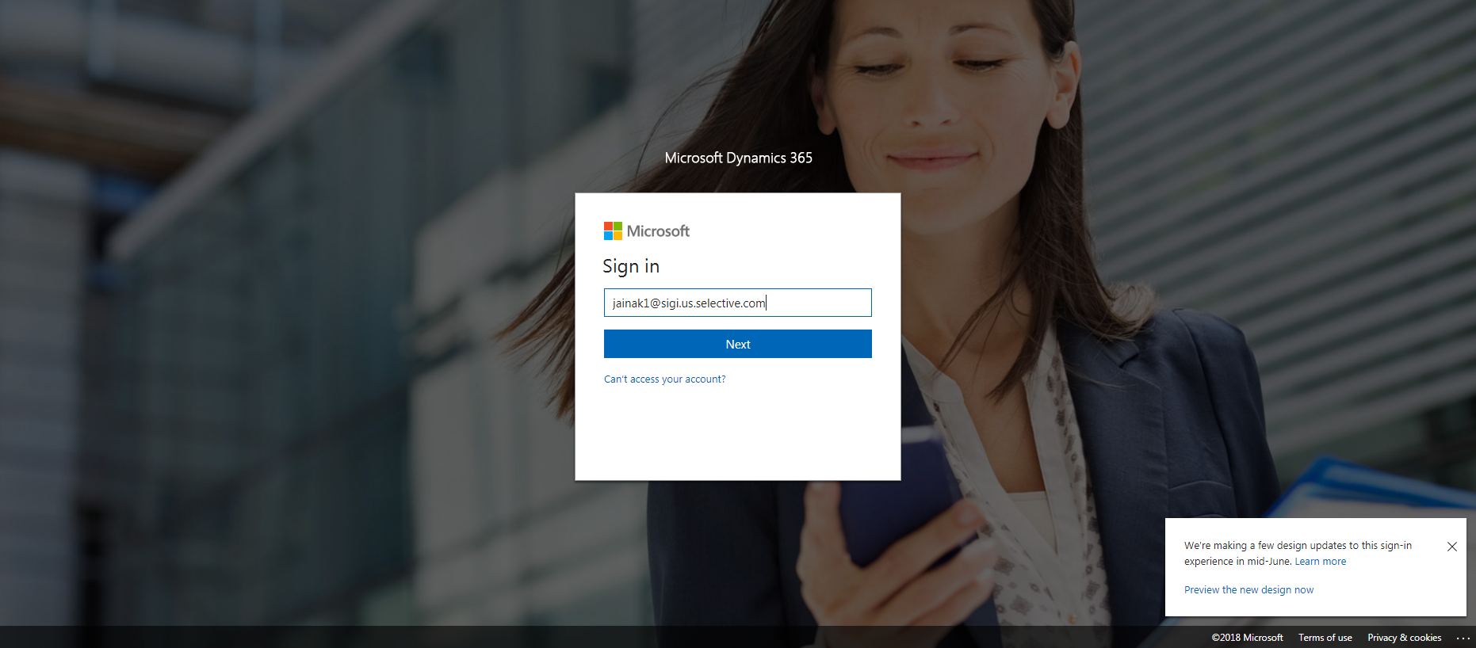

Policies_Verifying Agency Billed Policy_Instance43_15-Jun-2018_07-03-16_AM_SingleSignOn.png

